**Assignment 1**

Due: By midnight on Saturday, November 19th, via Canvas.

Have one person from each group upload either: a) a self-contained Jupyter notebook, with all the discussion and “storytelling with analytics” embedded in the notebook, or b) if you plan to use the “Excel to Gurobi” notebook, you can submit your input.xls file along with a Word document containing your discussions and storytelling (with screenshots of Gurobi results as needed). If you are taking option a), then be sure your notebooks are well-documented (e.g., clear labeling of variables, markdown text and comments clarifying steps of the code), so that someone who has not developed the model can easily understand it and replicate your results and findings. If you are taking option b), make sure your input file is clearly labeled, so that it’s clear what the objective, decision variables, and constraints of your model are.

1. **Kidney Exchange Optimization**

The Kidney Paired Donation (KPD) program is a voluntary kidney exchange program operated by Canadian Blood Services (CBS) (you can read more about it [here](https://www.blood.ca/en/organs-tissues/living-organ-donation/kidney-paired-donation)). Periodically, when the number of donor/patient pairs in the KPD pool reaches a certain size, CBS runs an algorithm to maximize the number of transplants achievable through compatible exchange cycles (recall the examples we went over on day 1). This question involves a slightly simplified version of the real process, but captures the essence of the underlying optimization problem.

Before receiving a kidney transplant, both patient and donor must undergo a thorough medical evaluation to make sure that they are both blood type compatible and tissue type compatible. For instance, a patient with A blood type and tissue type 1 kidney can only receive a kidney from a donor with A or O blood type and tissue type 1 kidney. The following table gives the compatibility of blood types (BT) between donors and patients, with a check mark meaning a donor with the blood type shown in that row can donate to a patient with the blood type shown in that column. Assume that in addition to the blood type compatibility rules, the donor’s tissue type must match exactly with the patient’s tissue type. Also, assume that a donor in one pair won’t give to another patient in another pair unless their loved one also receives a transplant from some donor in the pool. In other words, we are not considering altruistic donors in this setting.

|  |  |  |  |  |
| --- | --- | --- | --- | --- |
|  | Patient’s BT | | | |
| Donor’s BT | A | B | AB | O |
| A | ✓ | 🗶 | ✓ | 🗶 |
| B | 🗶 | ✓ | ✓ | 🗶 |
| AB | 🗶 | 🗶 | ✓ | 🗶 |
| O | ✓ | ✓ | ✓ | ✓ |

Currently, there are 25 pairs in the KPD pool; see ‘KPD_pool.csv’ for details.

1. Clearly write out the algebraic formulation of the optimization problem that maximizes the number of kidney transplants achievable from this pool.

**Answer:**

**Objective function:**

$$maximize: \sum_{i,j}{x_{i,j}}$$

**Decision variables:**

$$x_{i,j}=0 or 1$$

$x_{i,j}$ are binary variables which only take value 0 or 1,

$i$ represents the list of donors

$j$ represents the list of patients

$x_{i,j}=1$ means transplant should be make between donor i and patient j

$x_{i,j}=0$ means transplant should not be make between donor i and patient j

**Constraint 1: Netflow for each node equals 0**

$$\sum_{i∈I}{x_{i,j}}−\sum_{k∈K}{x_{j,k}}=0 for j =1,2,3,...,25$$

$\sum_{i}{x_{i,j}}$ represents the total inflow of donation for node j

$\sum_{k}{x_{j,k}}$ represents the total outflow of donation for node j

**Constraint 2: Total inflow for each node equals to or less than 1**

$$\sum_{i∈I}{x_{i,j}}<=1 for j =1,2,3,...,25$$

This help ensure that each pair receive no more than 1 time.

**Constraint 3: Total outflow for each node equals to or less than 1**

$$\sum_{k∈K}{x_{j,k}}<=1 for j =1,2,3,...,25$$

This help ensure that each pair donate no more than 1 time.

**Constraint 4: Some of donations from donor j to patients i is not feasible**

$$x_{i,j}=0 for some (i,j) pairs$$

1. Solve your formulation using Python/Gurobi to determine the maximum number of transplants, along with an indication of which donors should give to which patients to achieve this total.

**Answer:**

According to the results of Gurobi, the maximum number of transplants is 13, the feasible routes are as follows:

2→15→2

4→22→4

6→14→6

10→16→17→10

11→19→23→20→11

*The numbers here represent the donor-patients pairs, and the route ”a→b” means transplant from pair a donor to pair b patient.

The diagram is shown as follows:

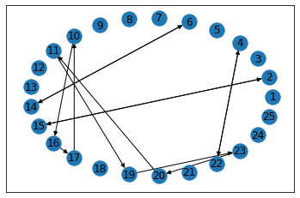

1. Provide some managerial discussion of your solution; e.g., any interesting observations regarding the solution, any potential practical challenges in implementing it, other factors that might be considered, etc. (1 paragraph).

**Interesting observations**:

There are multiple optimal solutions for this problem, which all reach to maximum transplants of 13.

**Challenges**:

As there are multiple possible solutions for this problem, conflict of interest will occur between the patients in different pairs as because if we apply one solution, the pairs not in our applied solution but in the other optimal solutions will be ignored for the transplant opportunities, so it is really difficult to decide which solution to actually apply into reality.

**Other factors might be considers**:

The state of illness of the patients: we should add weights to severity of illness for the patients when making decisions, and we might prioritize the ones with more sever illness for transplants.

**2. Multi-Period Production Planning**

An airplane company is scheduling the production of jet engines for the next four months. To meet contracted dates for delivery, the company must supply engines for installation according to a schedule. Due to various other ongoing work at the production facilities, production capacity and costs vary over the next four months. Assume production in a month is completed soon enough so that those engines can be used for installations that same month. Also, engines produced in one month can be stored for installation in a later month.

The following table contains relevant data for this problem.

|  |  |  |  |  |
| --- | --- | --- | --- | --- |
| **Month** | **Scheduled Installations** | **Maximum Production** | **Unit Production Cost**  **(million $)** | **Unit Storage Cost**  **(million $)** |
| 1 | 10 | 25 | 1.08 | .015 |
| 2 | 15 | 35 | 1.11 | .015 |
| 3 | 25 | 30 | 1.10 | .015 |
| 4 | 20 | 10 | 1.13 | - |

1. How many jets should the company produce each month so as to meet the scheduled installations at minimum total cost (production + storage)? Formulate an optimization problem that solves this problem. Note, there are different ways one might go about this. In fact, it can it can be formulated as a type of transportation problem using a clever definition of supply and demand nodes. Provide your algebraic formulation as well as your solutions here.

**Answer:**

**Objective function:**

$$maximize: 1.08X11+1.095X12+1.11X13+1.125X14+1.11X22+1.125X23+1.14X24+1.11X33+1.115X34+1.13X44$$

**Decision variables:**

X11, X12, X13, X14, X22, X23, X24, X33, X34, X44

Xij here means the amount produced in month i and installed in month j. where $i≤j$.

**Constraints 1: Production capacity**

$$X11+X12+X13+X14 ≤25$$

$$X22+X23+X24 ≤35$$

$$X33+X34 ≤30$$

$$X44 ≤10$$

**Constraints 2: Installation schedule**

$$X11=10$$

$$X12+X22=15$$

$$X13+X23+X33=25$$

$$X14+X24+X34+X44=20$$

**Constraints 3: Non negativity**

$$X11, X12, X13, X14, X22, X23, X24, X33, X34, X44≥0$$

The results from Gurobi is as follows:

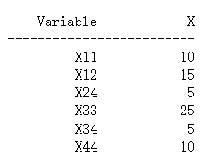

The optimal solution is as follows:

|  |  |  |  |  |
| --- | --- | --- | --- | --- |
|  | Month 1 installation | Month 2 installation | Month 3 installation | Month 4 installation |
| Month 1 production | 10 | 15 | 0 | 0 |
| Month 2 production | 0 | 0 | 0 | 5 |
| Month 3 production | 0 | 0 | 25 | 5 |
| Month 4 production | 0 | 0 | 0 | 10 |

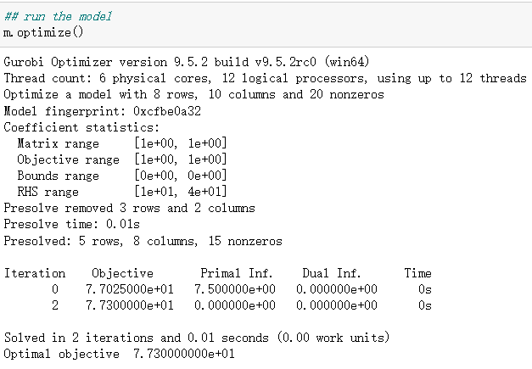

The optimal cost is $77.3 million.

1. Provide some managerial discussion of your solution; e.g., any interesting observations regarding the solution. Include a discussion of the key trade-offs in this type of problem. (1 paragraph).